Currency Exchange

James LeBlanc

Company Background

December 4, 2015

Table of Contents

Company Background 2

Management Team 3

Support Staff 4

Organization Chart 5

References 5

# Company Background

**Name of Company**

Currency Exchange

**Address**

New York, NY

**Legal Structure**

LLC – Currency Exchange is a new company owned by President and CEO James LeBlanc. The exchange will operate under the BitLicense issued by New York State Department of Financial Services. (“NYS Department of Financial Services,” 2015) The exchange will also acquire the Transmitter of Money License also issued by New York State Department of Financial Services. The Chief Compliance officer will coordinate the acquisition and retention of the appropriate licenses.

**Intellectual Assets and Protection**

The company’s Logo and Name which will appear on all marketing materials and throughout the web portal will be trademarked. Currency exchange will design build and maintain comprehensive proprietary software platform to operate the exchange. We will also design and maintain a web portal with versions for PC’s, tablets and Smartphones. All software will be copy written by the exchange.

## Management Team

**James LeBlanc, President and CEO**

**Chief Financial Officer**

**Summary:** Responsible for overseeing and directing the organization's financial goals, objectives, and budgets. CFO will meet with the Board and other company executives to develop financial goals and budgets.

**Chief Information Officer**

**Job Description:** Responsible for the technological direction of a company. Proposes budgets for programs and projects, purchases and upgrades equipment, supervises computer specialists and IT workers, and presides over IT-related projects.

**Chief Technology Officer**

**Job Description:** Responsible for developing, enhancing, and deploying a company's web presence. CTO ensures execution of company's business goals and strategies.

**Chief Operation Officer**

**Job Description:** Responsible for overseeing and guiding the day-to-day operations of a company. Presides over; revenue and sales growth, expense, cost and margin control, and monthly, quarterly and annual financial goal management.

**Chief Compliance Officer**

**Job Description:** The Chief Compliance Officer oversees the companies Compliance Program, functioning as an independent and objective body that reviews and evaluates compliance issues/concerns within the organization. The position ensures the Board of Directors, management and employees are in compliance with the rules and regulations of regulatory agencies, that company policies and procedures are being followed, and that behavior in the organization meets the company’s Standards of Conduct.

**Education/Experience Required:** A Legal degree plus 7 years’ experience working in compliance.

## Support Staff

**Customer Service representative**

**Job Description:** The position is the face of the company and will interact directly with customers.

**Software Developer**

**Job Description:** The position will be responsible for the design and development of the exchange software.

## Organization Chart

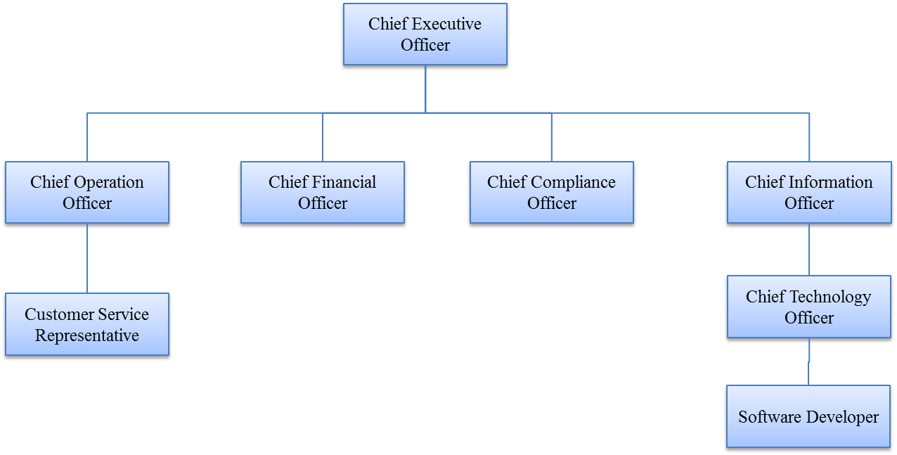

# References

NYS Department of Financial Services. (2015). Retrieved from

http://www.dfs.ny.gov/legal/regulations/adoptions/dfsp200t.pdf